Simple CALCULATOR

Create the following Web page with the heading 'Calculator' and provided images.

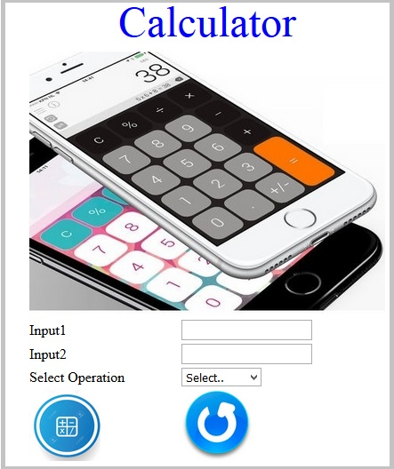

The web page should contain following input elements and apply the specified Constraints:

|  |  |  |
| --- | --- | --- |
| Label Name | Element Name | Constraints |
| Input1 | input1 | This element is to get the first input. Type should be 'number' |
| Input2 | input2 | This element is to get the second input. Type should be 'number' |
| Select Operation | operation | A drop down list contains the following values: **Select..** , **ADD, SUBTRACT, MULTIPLY and DIVIDE.**  **Set these values as its option tag text and option tag's 'value' attributes** |
|  | submit | An input field with image as type. |
|  | reset | An input field with image as type. |

Consider the images are in the current folder and

* Use “calculator.jpg” as a header image.
* Use “calc.jpg” as calculation button and “reset.jpg” as reset button.

**Apply following styles to the attributes**: Do not use CSS .

1. The heading should be done using the font color as 'blue' and with font size as '20'. (Use <font> tag)
2. The height and width of the images with the name “submit” and “reset” should be '80'.
3. The height and width of the calculator image should be '300' and '400'.